

Developing a Multi-functional Multi-core APP4MC-Platform Demonstrator and
Evaluating Parallelization Outcomes

A Documentation

By

Mustafa Özcelikörs

___________________
Date

TABLE OF CONTENTS
Chapter Page
TABLE OF CONTENTS iii
LIST OF TABLES iv
LIST OF FIGURES v
CHAPTER I: Introduction and Feature Overview 1
CHAPTER II: Hardware Setup 5
Overall Setup and Connections 5
Communication Protocols 5
Power Supply and Safety Measures 6
CHAPTER III: XMOS Software Overview 7
XMOS, XS1 Architecture and xC Overview 7
Implemented Software 7
Implemented and Existing Software Interfaces 8
Parallelism 8
Implemented Functions and their Configurations on XMOS 8
Reading Sonar (Proximity) Sensors and Using I2C Protocol 8
Actuation of Electric Motor for Speed Control (by Implementing PWM Protocol) 8
Actuation of Servo Motor for Direction Control (by Implementing PWM Protocol) 9
Receiving and Parsing Bluetooth Messages 9
TCP (Ethernet) Server Application 9
Monitoring Core Utilization/Usage 9
Safety Measures 9
CHAPTER VI: Raspberry Pi Software Overview 10
Introduction to Raspberry Pi and Debian/Raspbian Shell Scripting 10
Implemented Functions and their Configurations on Raspberry Pi 10
Webcam Server 10
Display Module 10
TCP (Ethernet) Application 10
Apache Web Server and Implemented Web page 10
Display Module 10
Initializing and Configuring All the Software on Raspberry Pi 10
Safety Measures 10
REFERENCES 11

LIST OF TABLES
Table Page
No table of figures entries found.

LIST OF FIGURES
Figure Page
Fig 1. TT-01 Type-E Chassis and Other Components 2
Fig 2. Designed 3D model 2
Fig 3. RCCAR 3D Printed Extension 3
Fig 4. RCCAR Mechanical/Hw Setup 4
Fig 5. Communication protocol tree for XMOS 5

CHAPTER I: Introduction and Feature Overview
APP4MC-based Multicore RCCAR is a demonstrator RCCAR for the APP4MC platform. It features distance sensor reading, actuation with both servo and electrical motors, an SMI (10Mbit) TCP connection and TCP command parsing, core monitoring functions, bluetooth command receiving and parsing functions on the low-level side that are controlled by XMOS xCORE-200 16-core Microcontroller. High-level side, which is controlled by a Raspberry Pi, features several more functions. Those high-level functions include hosting an Apache Web Server with PHP5 (that is also capable of running AJAX and jQuery based Dynamic Web pages), a Webcam server using the module mjpg-streamer, Core usage retrieval and display functions, a display module that is used for showing core utilization and a TCP client application which is used for talking with the low-level side, the xCORE-200. It also features an OpenCV 3.0-ready platform with Raspberry Pi where image processing function implementation is further possible. This report involves the hardware and software setup and installation regarding APP4MC-based Multicore RCCAR.
RCCAR features mechanical, electrical, and software components that should be installed delicately in order to function. RCCAR chassis and body is taken from a Professional RCCAR kit which is called TT-01 Type-E Chassis. The chassis is shown in Fig 1.
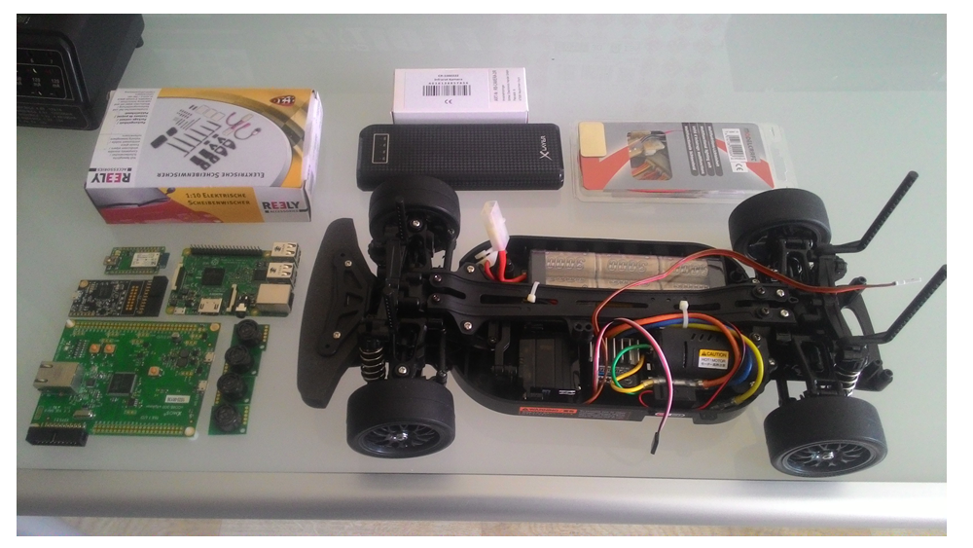
Fig 1. TT-01 Type-E Chassis and Other Components

RCCAR mechanical body is extended by an extension platform that is designed using Google SketchUp (in Fig 2) and that is 3-D printed. After chassis and other primary components are installed, the RCCAR looks as in Fig 3.
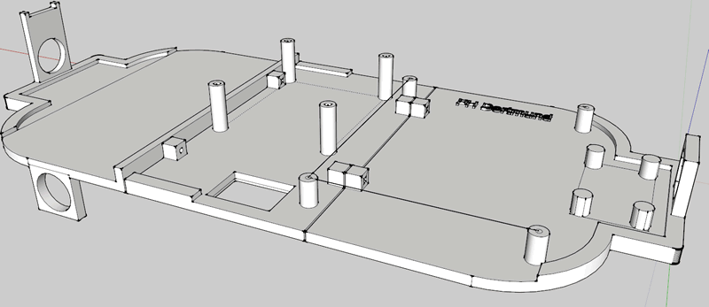
Fig 2. Designed 3D model
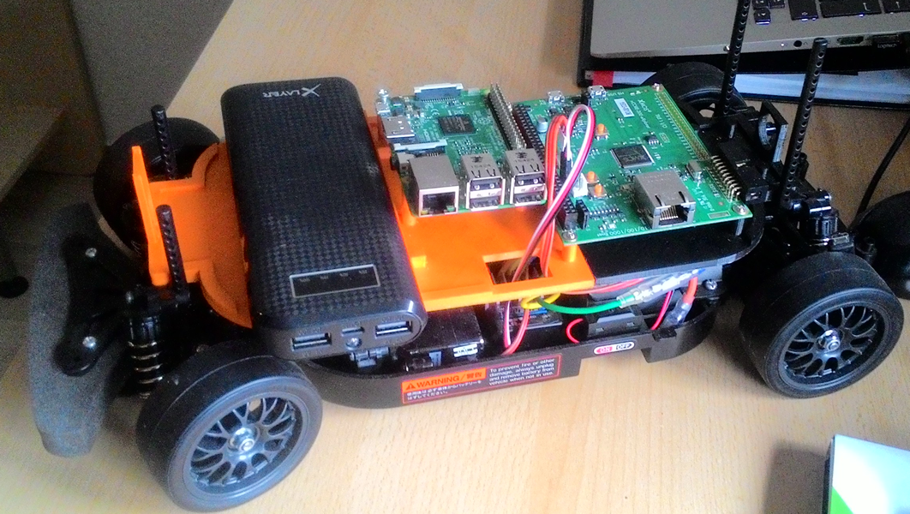
Fig 3. RCCAR 3D Printed Extension

RCCAR mechanical setup is given in Fig 4. In the figure, it is seen that the RCCAR features a 3D printed extension, Raspberry Pi, an xCORE-200 16-core Microcontroller, a RN-42 Bluetooth module, Raspberry Pi Camera, Powerbank, 4x SRF02 Sonar sensors, A servo motor, and a TBLE-02 Electronic Speed Controller. It should be noted that there are a few more components in the RCCAR which are not shown in Fig 4. Those components include a 5V to 3.3V level-shifter and a 5V DC-DC Isolated Converter Module. These components will be detailed in the hardware setup section.

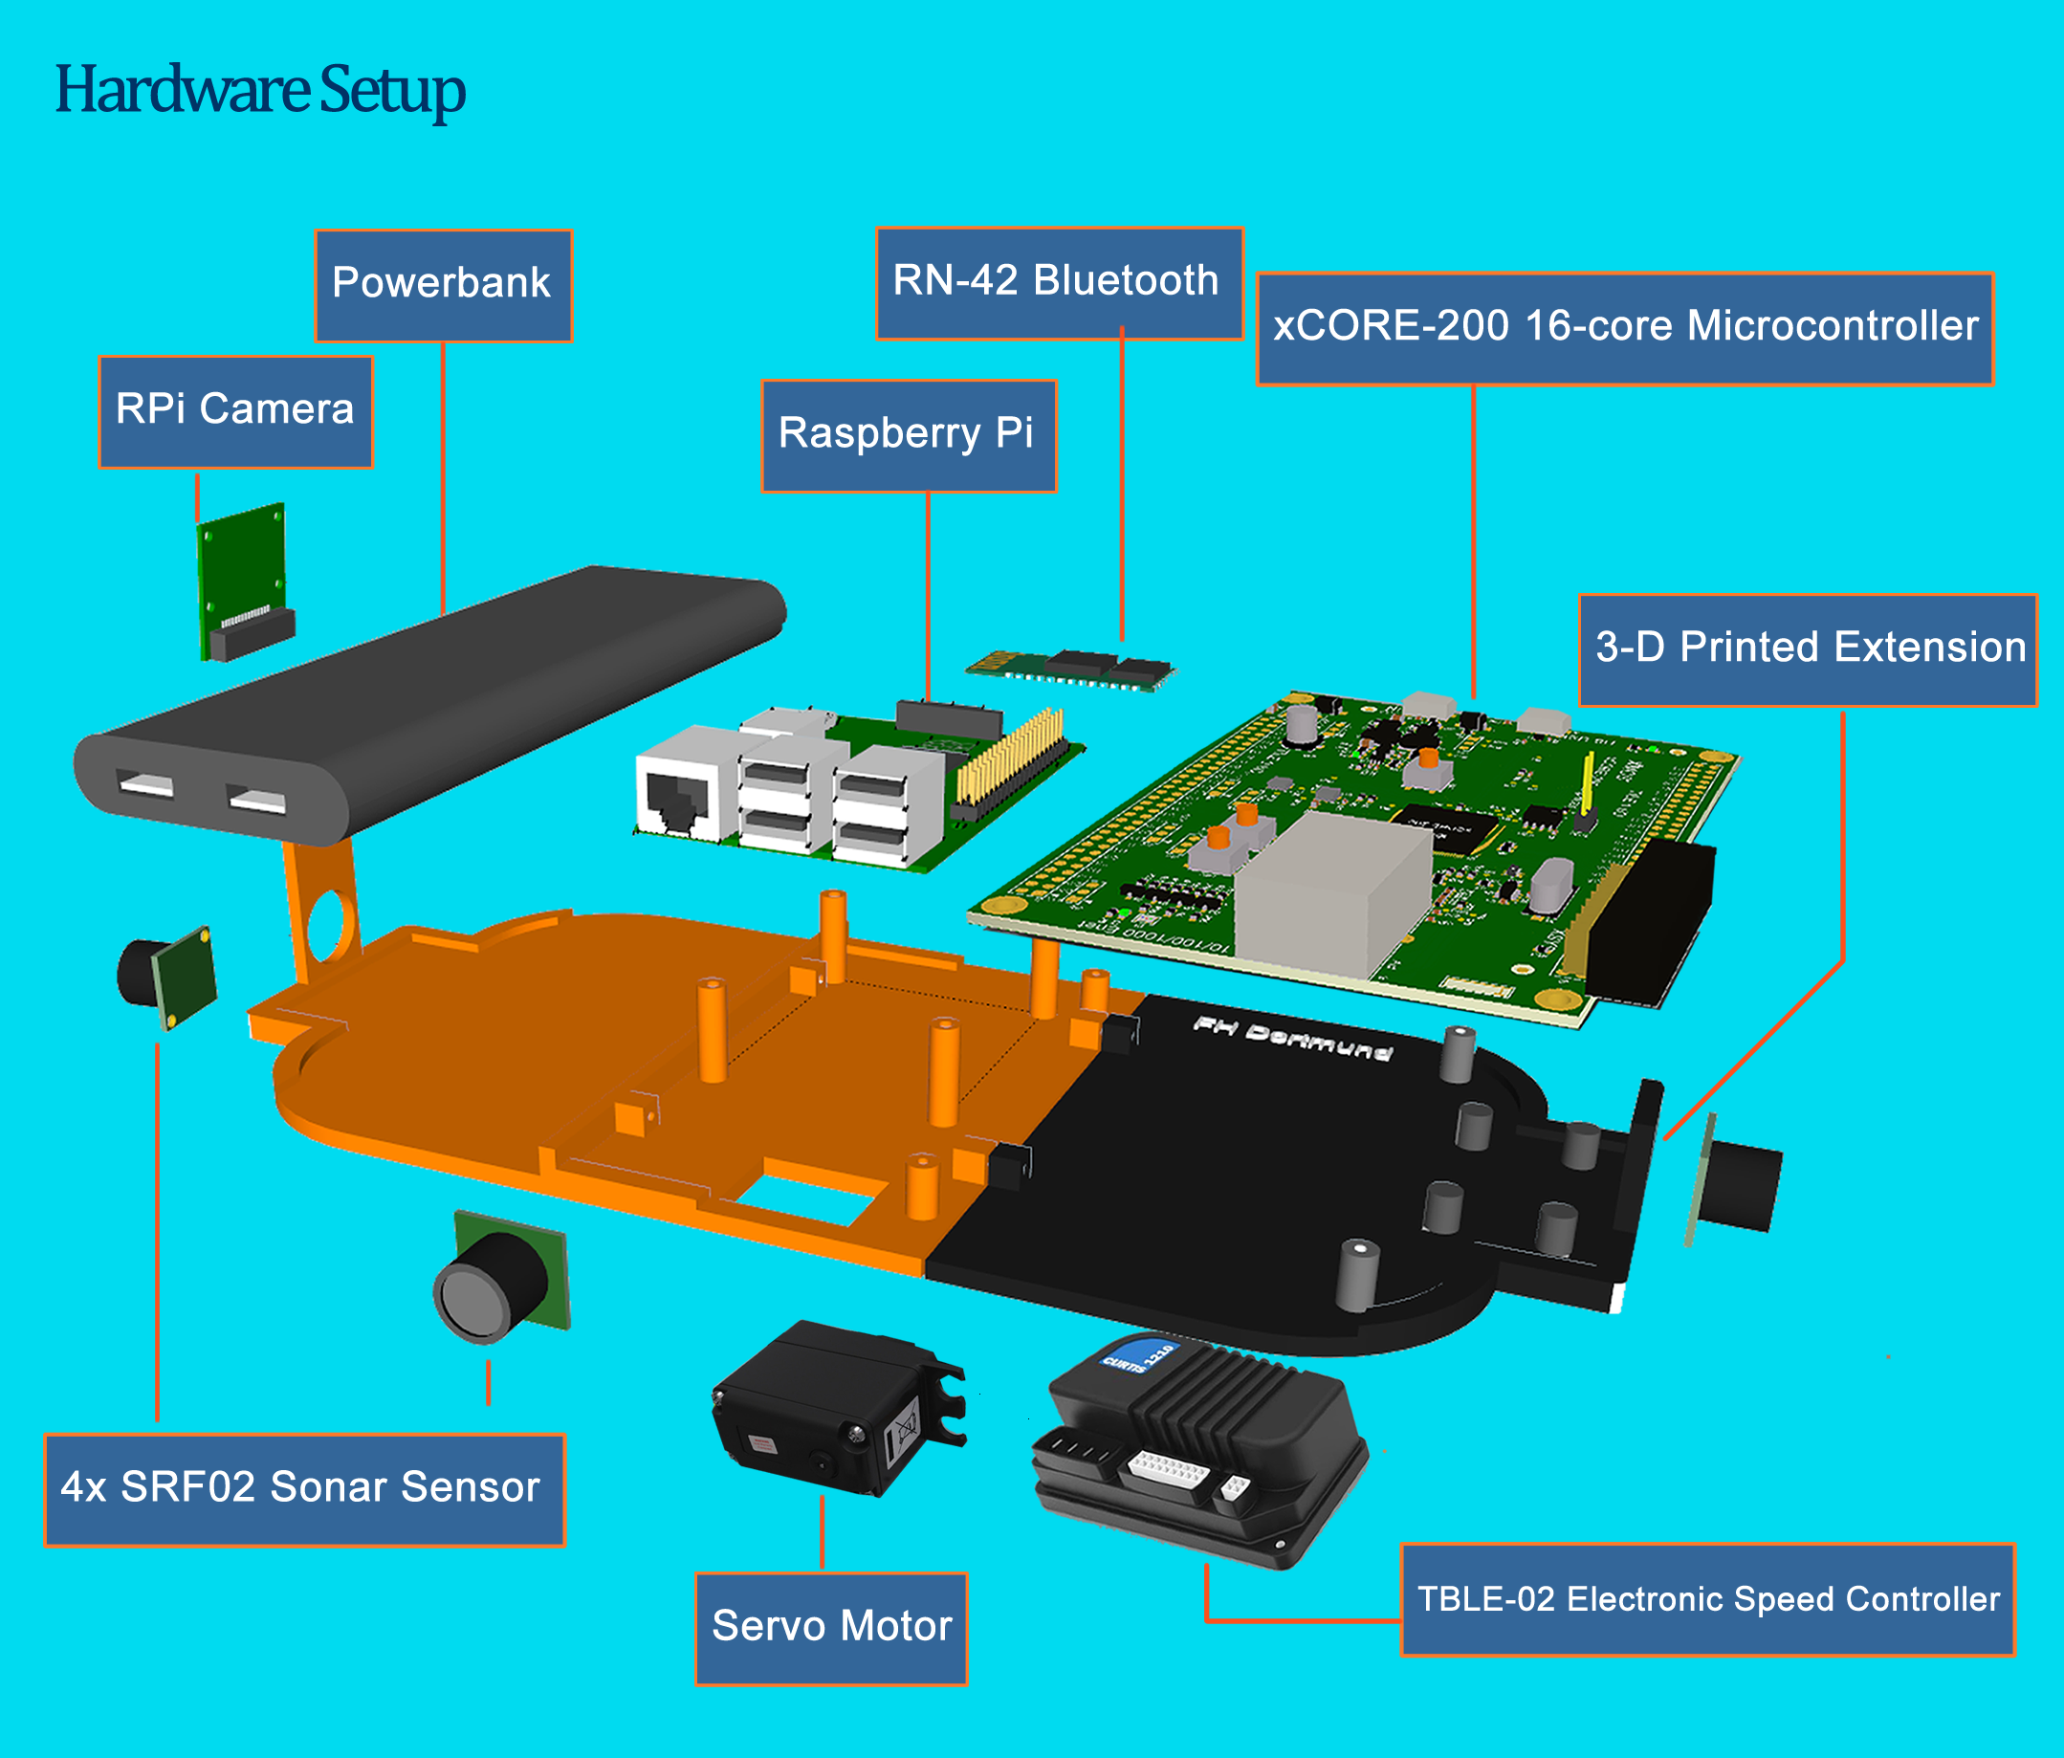
Fig 4. RCCAR Mechanical/Hw Setup

CHAPTER II: Hardware Setup

Overall Setup and Connections

Communication Protocols
The system features several communication protocols mostly lying on the low-level (XMOS) side. Those protocols involve PWM, I2C, UART, and TCP. The communication protocol tree is shown in Fig 5. Software implementations of these protocols is discussed in the Software Setup chapter.
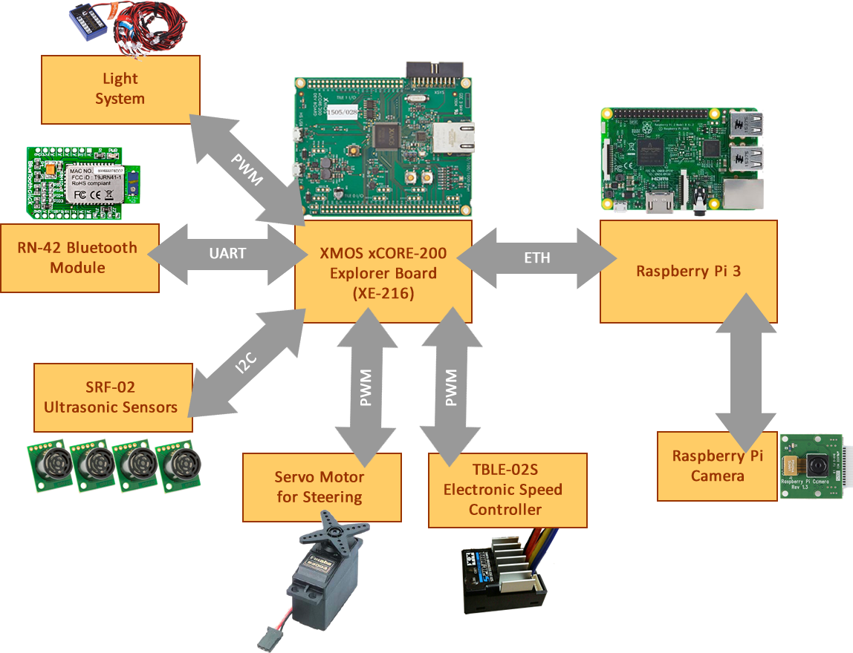
Fig 5. Communication protocol tree for XMOS

Power Supply and Safety Measures

CHAPTER III: XMOS Software Overview

XMOS, XS1 Architecture and xC Overview
event-driven

Implemented Software
Software regarding low-level functionality of APP4MC-based RCCAR is created using the development environment xTIMEcomposer 14.2.0. As mentioned, these low-level functions involve bluetooth command receiving and parsing, TCP server application implementation, sonar proximity sensor data reading, and RCCAR actuation functions using both electrical and sonar motors. In Fig, the workspace that is provided with APP4MC is given.
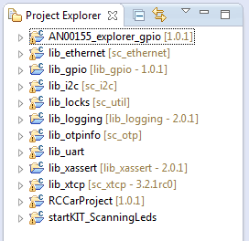
As the Fig suggests, when developing with xTIMEcomposer, all the libraries needed should also be imported as a project to the Project Explorer window. The software implemented uses lib_ethernet, lib_gpio, lib_i2c, lib_locks, lib_logging, lib_otpinfo, lib_uart, and lib_xassert libraries provided by the XMOS website. The project files are included in the RCCarProject>src folder. Inside the src folder, following content will be seen:
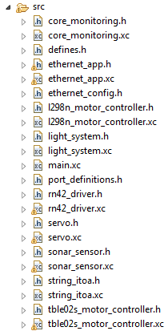
Each of these files contain one or more functions or task functions that serves a particular purpose. Each of the functions will be explained in the later sections.

Implemented and Existing Software Interfaces

Parallelism

Implemented Functions and their Configurations on XMOS

Reading Sonar (Proximity) Sensors and Using I2C Protocol

Actuation of Electric Motor for Speed Control (by Implementing PWM Protocol)

Actuation of Servo Motor for Direction Control (by Implementing PWM Protocol)

Receiving and Parsing Bluetooth Messages

TCP (Ethernet) Server Application

Monitoring Core Utilization/Usage

Safety Measures

CHAPTER VI: Raspberry Pi Software Overview

Introduction to Raspberry Pi and Debian/Raspbian Shell Scripting

Implemented Functions and their Configurations on Raspberry Pi

Webcam Server

Display Module

TCP (Ethernet) Application

Apache Web Server and Implemented Web page

Display Module

Initializing and Configuring All the Software on Raspberry Pi

Safety Measures

REFERENCES
[1] ...

